Packet Analysis and Networking Basics Quiz

Question 1:
List the factors to consider when choosing a packet sniffer.
Your Answer:
Supported protocols
user friendly
cost
program support
source code access
operating system support

Question 2
List and explain the basic operations of a packet sniffer.
Your Answer:
Collection--This is the first step and this is where they collect the raw information of the data. For this to happen they need to be in promiscuous mode.
Conversion-- This translates to readable form from the binary data.
Analysis-- Then we get the analysis and then it starts to convert the data. You can then analyze the specific information.

Question 3

List and explain the basic functions of networking protocols.
Your Answer:
Connection initiation-- what information? What are you asking for?
Negotiation of connection characteristics-- Is it encrypted, how much security is there?
Data formatting-- How is it organized?
Error detection and correction-- what happens if it takes a long time? what issues.
Connection termination--what is the final transmission? what needs to be sent?

Question 4

List, either in ascending or descending order, the layers of the OSI model.

Your Answer:
7. Application
6. Presentation
5. Session
4. Transport
3. Network
2. Data Link
1. Physical

Question 5

Explain data encapsulation as it pertains to data movement throughout the layers of the OSI model.

Your Answer:
The data encapsulation creates a TCP header and It goes from the PCA 7, 6, 5, 4, 3, 2, 1 to PCB 1, 2, 3, 4, 5, 6, 7 and they get the data.

Working with Captured Packets Assignment

Question 1
What is the most active IP address?
→ 192.168.0.115

Question 2
What is the number of HTTP redirects in this file? (Hint: HTTP redirects are HTTP response codes that are greater than or equal to 300, but less than 400.)
→ 4

Question 3
What is the average kilobytes per second being transmitted? (Numbers only, no letters)
→ 257

Question 4
How many total bytes are contained in this capture?
→ 1779036

Question 5
What is the UTC time of the first packet, rounded to the nearest hundredth second? (Formatting counts for this question…)
→ 2010-01-11 02:12:11.49

Question 6
What is the total time span of this capture, rounded to the nearest second?
→ 6 or 7

Advanced Wireshark Features Assignment- app-aptimize-off.pcapng
Question 1
What percentage of packets are UDP packets?
→ 3.5

Question 2
What percentage of UDP packets are DNS packets?
→ 100

Question 3
How many TCP connections are in this capture?
→ 15

Question 4
Filter this capture so only DNS packets are displayed. Export the result to a new file called YourName-DNS-export.pcap. Upload the export to this question. Name the file FirstnameLastnameDNSExport.pcapng.
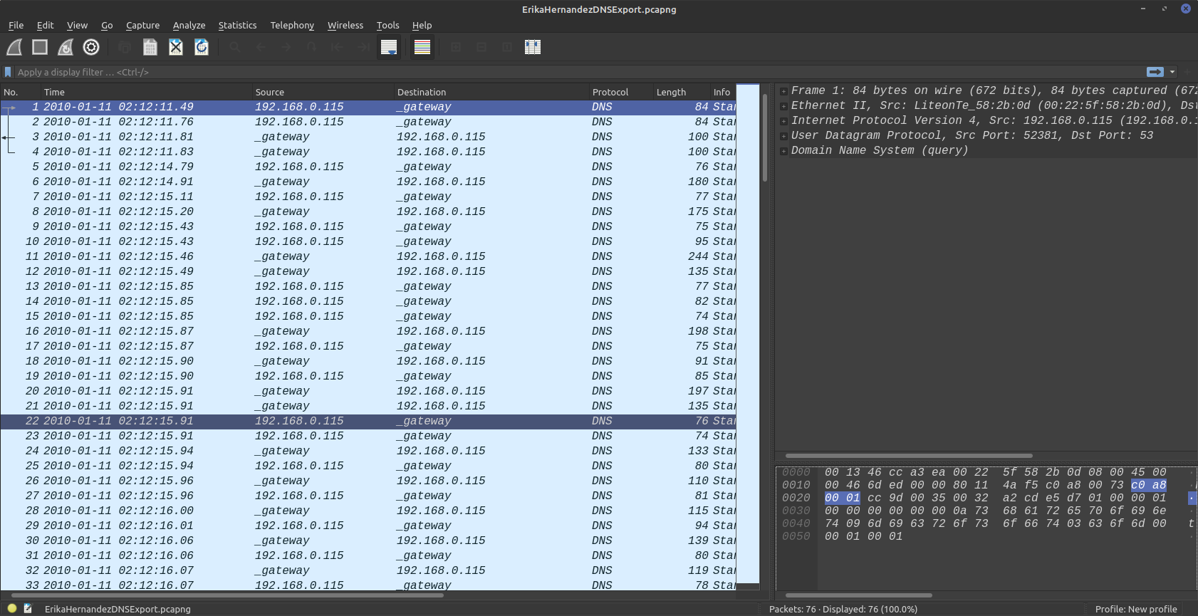
Ff
Question 5
Find and extract the favorites.png file from this capture. Attach the resulting file to this question.


Protocol Analysis from the Command Line Assignment

Question 1
What tcpdump command captures UDP traffic on network interface eth1?
→ tcpdump -i eth1 udp

Question 2

What tshark command captures traffic on source port 53 on network interface eth0?
→ tshark -i eth0 -f "src port 53"

Question 3

What tcpdump command captures traffic going to 192.168.1.14 on network interface wlan0 and writes to a file called test.pcap?

→ tcpdump -i wlan0 dst 192.168.1.14 -w test.pcap

Question 4
What tshark command will read a pcap file called test.pcap and extract HTTP user agent strings?

→ tshark -r test.pcapng -T fields -e http.user_agent

